Sub-question 4: ‘'Which continent region did Dutch people choose as their favorite for vacation abroad per year, and has COVID-19 affected this choice?'

By examining flight volumes and travel patterns to different continents from the Netherlands, we aim to identify if preferences shifted due to the pandemic. This study focuses on trends from the pre-COVID period (2015-2019) and the post-COVID period (2022-2024).

Approach and assumptions

The analysis uses data filtered to capture travel from major Dutch airports (Amsterdam Schiphol, Eindhoven, and Rotterdam The Hague) to various continents. The time periods are segmented into pre-COVID (2015-2019) and post-COVID (2022-2024) for consistent comparisons. To focus on general trends, airport-specific data is combined.

Results

Figure 1: Total flights from Dutch airports to each continent from 2015 to 2024.

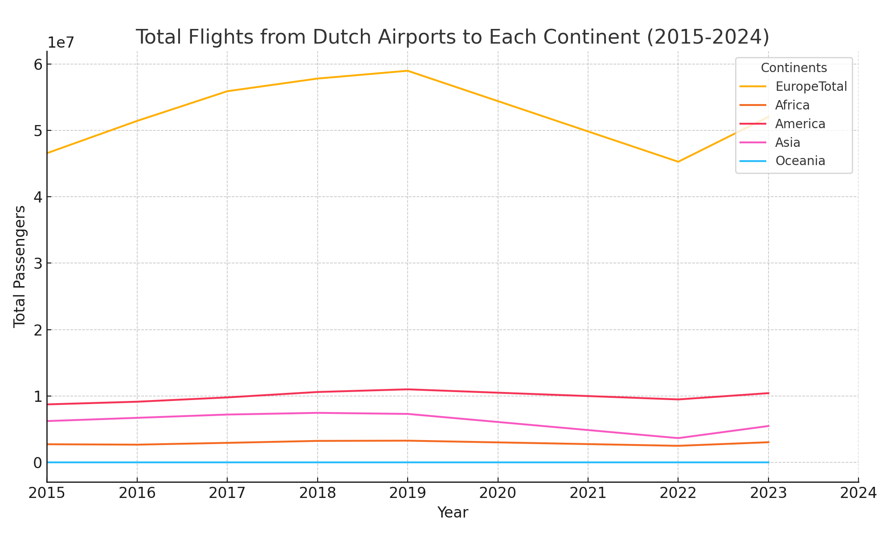

Figure 2: Percentage change in travel to each continent comparing pre-COVID (2015-2019) and post-COVID (2022-2024) periods.

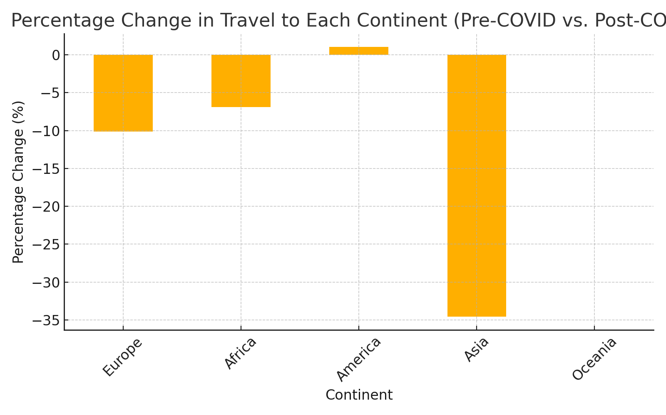

Figure 3: Comparison of Pre-COVID and Post-COVID Average Flights to Each Continent

|  |  |  |  |
| --- | --- | --- | --- |
| Continent | Pre-COVID Avg Flights | Post-COVID Avg Flights | Percentage Change |
| Europe | 54125374.8 | 48653087.0 | -10.11 |
| Africa | 2975557.6 | 2770983.0 | -6.88 |
| America | 9855213.6 | 9957485.5 | 1.04 |
| Asia | 6984097.4 | 4570430.0 | -34.56 |
| Oceania | 0.0 | 0.0 | nan |

4. Conclusion

The analysis reveals that Europe was consistently the most popular continent for Dutch travelers across all periods. However, COVID-19 had a significant impact on travel volumes to all continents, with Asia seeing the steepest drop due to stricter travel restrictions. Post-COVID, travel to Europe and the Americas rebounded faster, while Asia's recovery lagged. This suggests that COVID-19 altered travel patterns, with preferences shifting slightly due to accessibility and restriction levels in various regions.